**Marking scheme Of Website Development**

**SECTION A: Attempt All questions (55marks)**

**___________________________________________________________________________**

1. **Copy and complete the following table**

Ctrl + C: Copy

Ctrl + X: Cut

Ctrl + V: Paste

Ctrl + Z: Undo

Ctrl + A: Select all

Ctrl + F: Find

Ctrl + S: Save

Ctrl + P: Print

Ctrl + N: New window or document

Alt + Tab: Switch between open windows or applications

Windows key + D: Show or hide desktop

Windows key + L: Lock computer

Windows key + E: Open File Explorer

Windows key + R: Open Run dialog box

Windows key + I: Open Settings

SHIFT+CTRL+9 Unhide row

1. Can a keyboard layout affect typing speed and accuracy? If so, which layout is considered the most efficient?

**Answer/** yes, the keyboard layout can affect typing speed and accuracy. The efficiency of a keyboard layout is determined by the layout's design and how it accommodates the user's typing style and language.

There are many keyboard layouts available, but the most widely used are the QWERTY and the DVORAK layouts. The QWERTY layout is the most commonly used keyboard layout and was designed for typewriters in the 1800s. The DVORAK layout, on the other hand, was designed to be more efficient for typing and was developed in the 1930s.

1. What do you make remember to the following notions

**/* text */**

**<!--text -->**

Answer/

/* text */

<!--text -->

Allows you to insert comments in php and html codes

1. How do you clean a keyboard, and what should you avoid when doing so?

**Answer/** A. Unplug the Keyboard: Before cleaning the keyboard, unplug it from the computer or turn off the computer to avoid any accidental key presses.

* 1. Shake Out Debris: Turn the keyboard upside down and gently shake it to remove any loose debris like dust or crumbs.
  2. Use Compressed Air: Use a can of compressed air to blow out any remaining debris from between the keys.
  3. Clean the Keys: Use a soft, damp cloth and a mild cleaning solution, such as a mixture of water and a small amount of dish soap, to clean the keys. Be sure to wring out the cloth so that it is only damp and not dripping wet. Wipe the keys gently to avoid getting any moisture in the keyboard.
  4. Clean the Surface: Clean the surface of the keyboard with a soft, damp cloth and mild cleaning solution. Avoid using too much moisture, as it can damage the keyboard's electronics.
  5. Dry the Keyboard: Use a dry cloth to dry the keyboard thoroughly.

Things to Avoid:

1. Avoid using harsh chemicals, such as bleach, ammonia, or alcohol-based cleaners. They can damage the keyboard's surface and electronics.
2. Avoid getting water or cleaning solution into the keyboard. This can damage the keyboard's electronics.
3. Do not submerge the keyboard in water or other liquids.
4. Avoid using abrasive cloths or materials, such as steel wool or scrub brushes, which can scratch or damage the keyboard's surface.

1. What is the role of Embed tag in html document

**Answer / Embed is used to insert video or music into html page**

1. What are the different types of keyboard switches available, and what are the differences between them?

**Answer /** There are three main types of keyboard switches available:

1. Mechanical switches: These switches use individual mechanical components for each key, providing a tactile feedback and a "click" sound. They tend to be more durable and precise than other types of switches. They are preferred by gamers, programmers, and other users who need a high level of precision and responsiveness.
2. Membrane switches: These switches use a rubber dome with a conductive material on top of a circuit board. They are less expensive to produce and are usually found in lower-end keyboards. They provide less tactile feedback and are less durable than mechanical switches.
3. Scissor switches: These switches are similar to membrane switches but use a scissor-like mechanism to provide a more stable key press. They are commonly used in laptops and some slim keyboards.

.

1. Which one of the following is **NOT** a valid HTML tag?

<BODY> b) <TEXT> c) <H2>

**Answer:** Answer (b)

1. Which one of the following is in correct order of hierarchy (tags enclosing other tags)?
2. <BODY> , <TABLE>, <TR>, <TD>
3. <TABLE>, <TD>, <BODY>, <TR>
4. <TR>, <TABLE>, <TD>, <BODY>

**Answer:** Answer (a)

1. Using examples distinguish ordered list from unordered list

**Answer:**

**Ordered List**

<HTML>

<HEAD>

<TITLE> days </TITLE>

<META NAME="Generator" CONTENT="EditPlus">

<META NAME="Author" CONTENT="">

<META NAME="Keywords" CONTENT="">

<META NAME="Description" CONTENT="">

</HEAD>

<BODY><OL>

<LI>Manday

<LI>Tuesday

<LI>Wednesday

<LI>Thursady

<LI>Friday

</OL>

</BODY>

</HTML>

**Unordered List**

<HTML>

<HEAD>

<TITLE> days </TITLE>

<META NAME="Generator" CONTENT="EditPlus">

<META NAME="Author" CONTENT="">

<META NAME="Keywords" CONTENT="">

<META NAME="Description" CONTENT="">

</HEAD>

<BODY>

<UL>

<LI>Manday

<LI>Tuesday

<LI>Wednesday

<LI>Thursady

<LI>Friday

</UL>

</BODY>

</HTML>

1. What are the utility functions of the following tags and attributes:

<body></body>

<frameset></frameset>

<marquee></marquee>

Valign

Href

<hr>

**Answer:**

<body></body> Encloses the body(text and tags)of the document

<frameset></frameset>defines a framest

<marquee></marquee> is used to move text in HTML

Valign: the vertical aligment of the contents of the cell.

Href : the URL of document to be linked to this one.

<hr> horizontal rule line.

1. What are at least 3 roles of form

**Answer:**

Insert data

Collect data

Talk with user

**SECTION B: Attempt any Three (3) questions (30 marks)**

**___________________________________________________________________________**

1. Define the following terms and give the examples for each
2. Web site
3. www
4. Attribute
5. Tag
6. Browser

**Answer:**

1. **Web page** is a simple text written in description language called HTML permitting to describe the page set up of the document and to include the graphical element or links to another documents using the tags.

**Example: www.igihe.com**

1. **www** is the same as website means is set of many web pages linked between them

**Example: www.igihe.com**

1. **Attribute** is an element that is inside of an open tag which defines the property of that tag

**Example: <table border=”1”>**

1. **Tag**  they are basic commands of html document, they allow to define a document, the way it must be presented to the screen, how it must be used to the different users.

**Example: <html>COMTENT</html>**

1. **Browser** is a program that allows to interpret the html document on the client work station.

**Example: Microsoft Edge**

1. With examples explain multiple style sheets

## Answer:Multiple Style Sheets

If some properties have been set for the same selector in different style sheets, the values will be inherited from the more specific style sheet.

For example, an external style sheet has these properties for the h3 selector:

|  |
| --- |
| h3 { color:red; text-align:left; font-size:8pt } |

And an internal style sheet has these properties for the h3 selector:

|  |
| --- |
| h3 { text-align:right; font-size:20pt } |

If the page with the internal style sheet also links to the external style sheet the properties for h3 will be:

|  |
| --- |
| color:red; text-align:right; font-size:20pt |

The color is inherited from the external style sheet and the text-alignment and the font-size is replaced by the internal style sheet

1. State ten rules of Jacob Nielson for developing a web site

**Answer:**

1. Visibility
2. Standalization
3. Use control and freedom
4. Consistency and standard
5. Recognition than recall minimize the user’s memory
6. Flexibility and efficiency
7. Error prevention
8. Aestatic on minilist
9. Write a html code to produce the following out put :

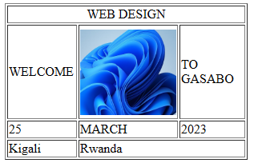

**Answer/** <html >

<head>

<title>Web exam</title>

</head>

<body>

<form method="post" action="">

<table width="303" border="1">

<tr>

<td colspan="3"><div align="center">WEB DESIGN </div></td>

</tr>

<tr>

<td width="85" height="118">WELCOME</td>

<td width="118"><img src="20.JPG" width="120" height="107" /></td>

<td width="90">TO GASABO </td>

</tr>

<tr>

<td>25</td>

<td>MARCH</td>

<td>2023</td>

</tr>

<tr>

<td>Kigali</td>

<td colspan="2">Rwanda</td>

</tr>

</table>

</form>

</body>

</html>

1. Write HTML code to produce the following output

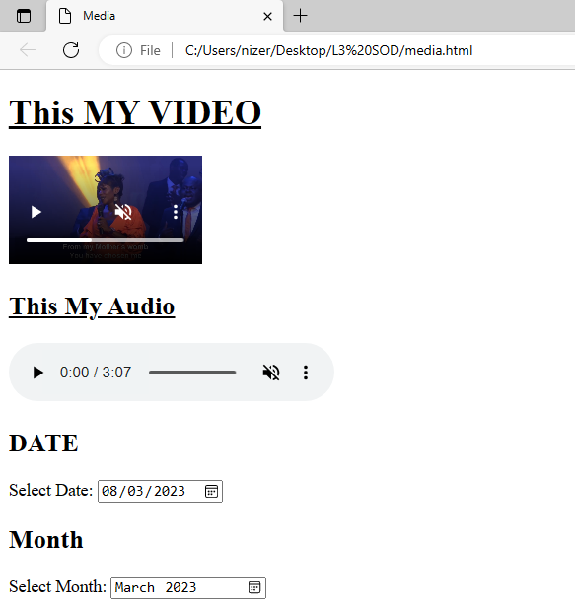

**Answer/** <!DOCTYPE html>

<html>

<head>

<meta charset="utf-8">

<meta name="viewport" content="width=device-width, initial-scale=1">

<title>Media</title>

</head>

<body>

<h1><u>This MY VIDEO</u></h1>

<video height="100" autoplay muted controls>

<source src="2.mp4" type="video/mp4">

</video>

<h2><u>This My Audio</u></h2>

<audio height="100" autoplay muted controls>

<source src="1.mp3" type="audio/mp3">

</audio>

<h2>DATE</h2>

<label>Select Date:</label>

<input type="date" name="date">

<h2>Month</h2>

<label>Select Month:</label>

<input type="Month" name="Month">

</body>

</html>

**SECTION C: Attempt only one (1) question (15 marks)**

**___________________________________________________________________________**

1. Talk about the application and differentiate the following tags with the examples

a) ID and Class

b) SPAN and DIV

**Answer:**

1. **Class** This attribute allows to create a specific class to HTML tag. It will always receive the name of an existent class as parameter.

If the style definition uses two languages (CSS or JavaScript) the utilization of style is unique for CSS or JavaScript

**ID** This attribute can be used for release an exception in class and it can be also be used only without class

1. **<SPAN> i**s used when you want to apply the style definitions to any block of text or thing which is not a tag of html. This allows to define a text block on which we apply the style referenced with an attribute “class”

**<DIV>** is used to organize a block of text, this tag has an attribute with their 3 parameter

<DIV align=”center”>

<DIV align=”left”>

<DIV align=”right”>

1. Write the HTML codes to produce the following out put

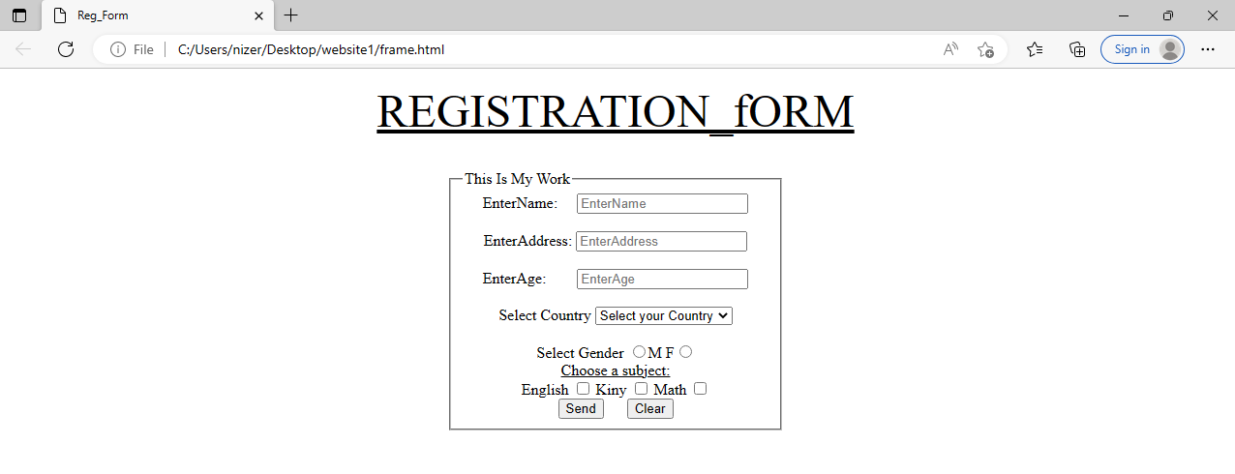

**Answer**

|  |  |
| --- | --- |
|  | <!DOCTYPE html> |
|  | <html> |
|  | <head> |
|  | <meta charset="utf-8"> |
|  | <meta name="viewport" content="width=device-width, initial-scale=1"> |
|  | <title>Reg_Form</title> |
|  | </head> |
|  | <body> |
|  | <center> |
|  | <p><font size="30%"><u>REGISTRATION_fORM</u></font></p><br> |
|  | <fieldset style="width:25%"> |
|  | <legend>This Is My Work</legend> |
|  | <label>EnterName:</label>&nbsp;&nbsp;&nbsp;&nbsp; |
|  | <input type="text" name="EnterName" placeholder="EnterName"><br><br> |
|  | <label>EnterAddress:</label> |
|  | <input type="text" name="EnterName" placeholder="EnterAddress"><br><br> |
|  | <label>EnterAge:</label>&nbsp;&nbsp;&nbsp;&nbsp;&nbsp; |
|  | &nbsp; |
|  | <input type="text" name="EnterName" placeholder="EnterAge"><br><br> |
|  | <label>Select Country</label> |
|  | <select> |
|  | <option>Select your Country</option> |
|  | <option>Rwanda</option> |
|  | </select><br><br> |
|  | <label>Select Gender</label> |
|  | <input type="radio" name="g">M |
|  | F<input type="radio" name="g"><br> |
|  | <u>Choose a subject:</u><br> |
|  | <label>English</label> |
|  | <input type="checkbox" name="subject"> |
|  | <label>Kiny</label> |
|  | <input type="checkbox" name="subject"> |
|  | <label>Math</label> |
|  | <input type="checkbox" name="subject"><br> |
|  | <input type="submit" value="Send">&nbsp;&nbsp;&nbsp;&nbsp;&nbsp; |
|  | <input type="reset" value="Clear"> |
|  |  |
|  | </fieldset> |
|  | </center> |
|  | </body> |
|  | </html> |

**END OF ASSESSMENT!**